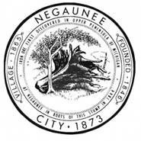
Nathan Heffron, City Manager
March 2, 2026
(For Immediate Release)
PRESS RELEASE
RE: Negaunee Ice Arena Public and Media Tour
City Manager Nate Heffron is announcing two tours of the Negaunee Ice Area for both the public and media to attend. The purpose of the tours will be to reveal designs for the proposed ice arena overhaul, which is needed to keep the facility operational to facilitate updates and repairs. Additionally, those that attend the tours will learn firsthand what is proposed, why, and be able to ask questions concerning the project.
The tour will be offered twice on March 25th. The first tour will start at 3:00 p.m. and the second will commence at 7:00 p.m., both will start in the lobby of the Negaunee Ice Arena.
Questions concerning this release may be directed to the attention of the City Manager, Nate Heffron at (906) 475-7700 ext. 11.

###

